**EX. NO:**

**DATE :**

**Decision tree classifier to predict signal quality based on transmitter,**

**signal strength, and frequency**

**AIM:**

create a simple dataset to classify signal quality based on various parameters such as

distance from the transmitter, signal strength, and frequency.

**PROGRAM:**

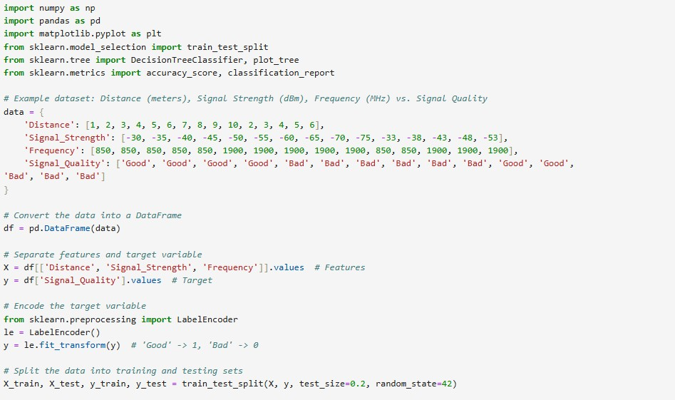

EX. NO : 09

DATE : 03/05/2024

220801140

**OUTPUT:**

**RESULT:**

T

his program is executed successfully.

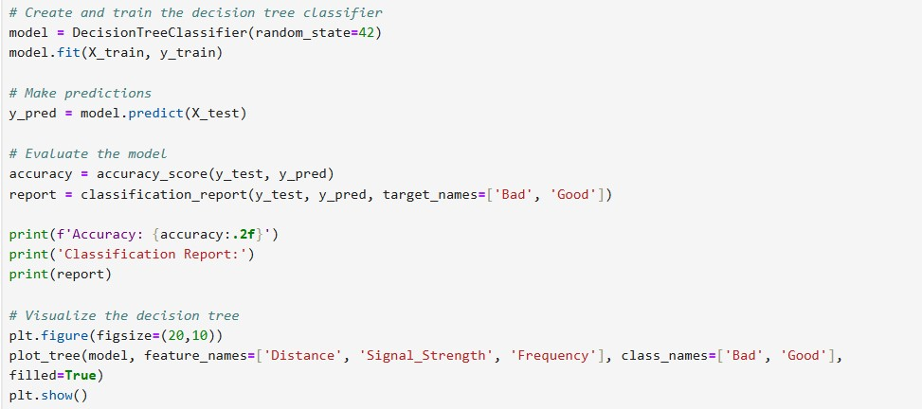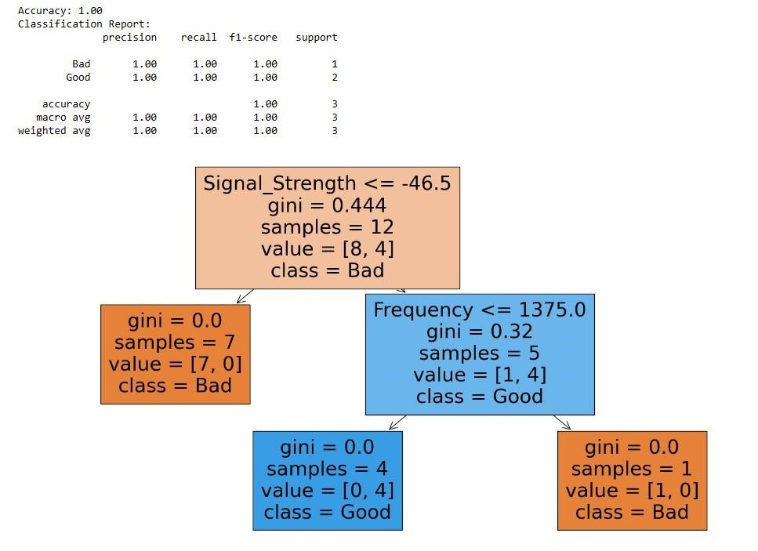

220801140